DANH SÁCH CÁC DỰ ÁN TIÊU BIỂU ĐÃ CẤP HÀNG
( LIST OF TYPICAL PROJECTS THAT HAVE BEEN DELIVERED)
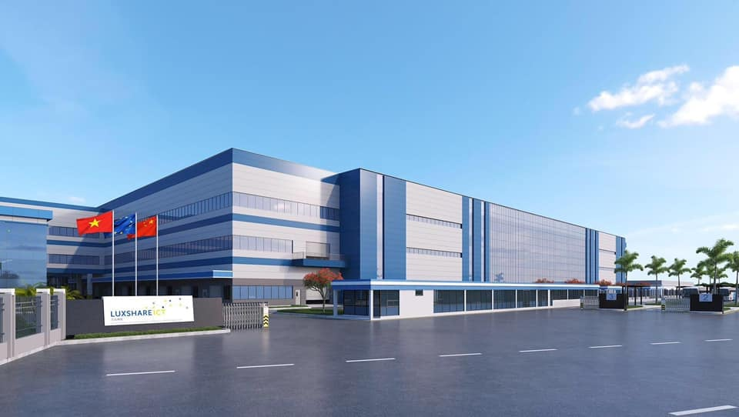
Dự án nhà máy LUXSHARE-ICT - Nghệ An
Khởi công năm :2020 .
Nhà thầu thi công: CÔNG TY CỔ PHẦN XÂY DỰNG HỢP LỰC
Khách hàng: Fisa

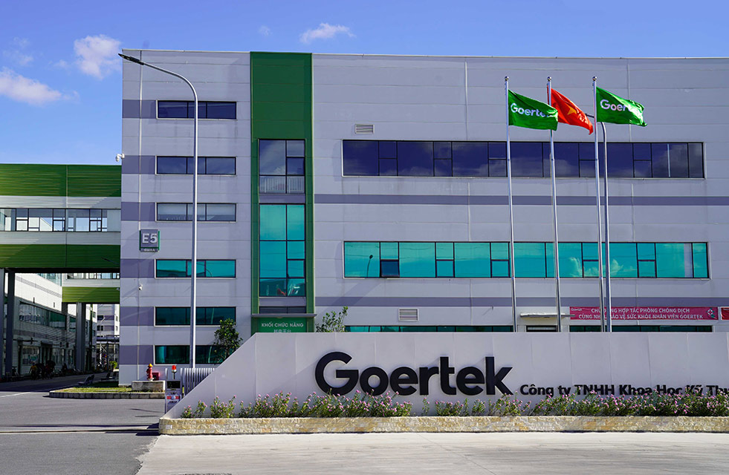
Dự án Goertek Vina : KCN Quế Võ-Nam Sơn-TP Bắc Ninh - Bắc Ninh
Khởi công năm :2021 .
Nhà thầu thi công: CÔNG TY CỔ PHẦN XÂY DỰNG HỢP LỰC
Khách hàng: Fisa

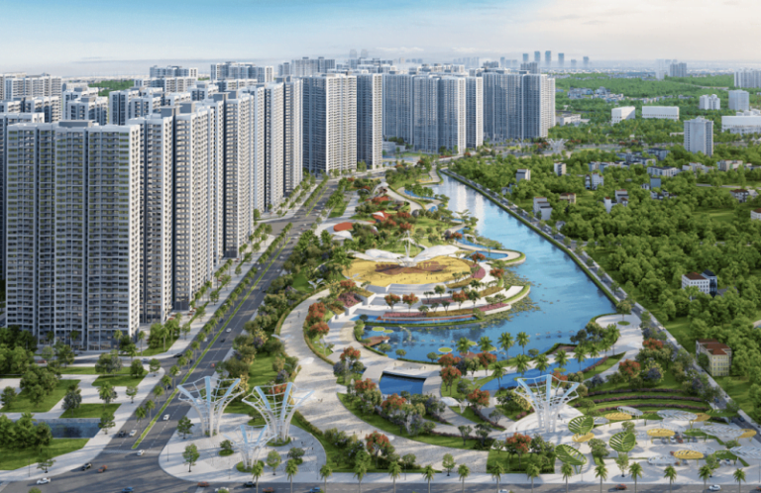
Dự án Vinsmart City IMPERIA- Tây Mỗ, Nam Từ Liêm, Hà Nội
Khởi công năm :2021 .
Nhà thầu thi công: CÔNG TY CỔ PHẦN CƠ ĐIỆN THỦ ĐÔ
Khách hàng: Fisa

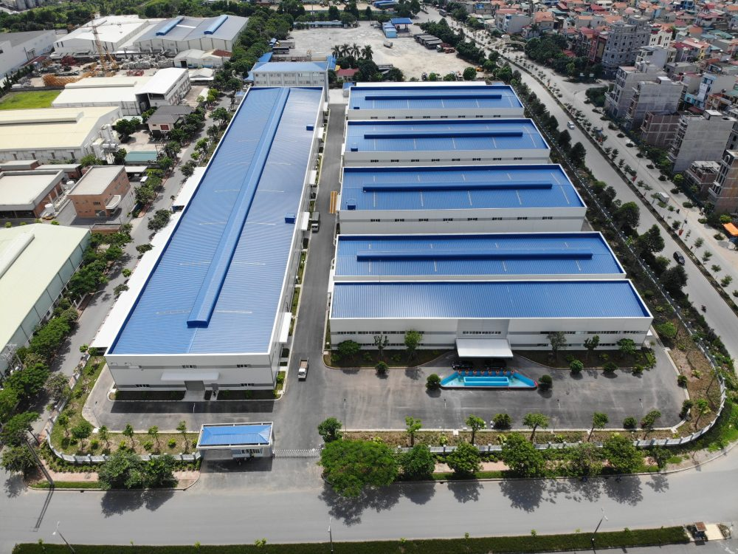
Dự án Nhà máy BYD - Phú Thọ
Khởi công năm :2021 .
Nhà thầu thi công: CÔNG TY CỔ PHẦN XÂY DỰNG HỢP LỰC
Khách hàng: Fisa

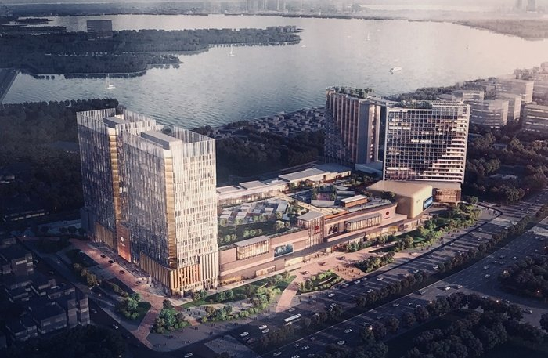
Dự án Lotte Mall Hanoi - Võ Chí Công Tây Hồ, Hà Nội
Khởi công năm: 2022.
Nhà Thầu Thi Công: TEMSO ; AKA
Khách hàng: Fisa


Chuỗi dự án Vin: Dự án Vinsmart City, Vin Nha Trang, Vin Phú Quốc, Vin ocean Park
Năm: 2022 – 2023.
Nhà Thầu Thi Công: VIN GROUP
Khách hàng: Fisa , Hưng Thinh, Tran Duy, CNCH.

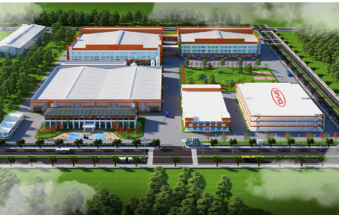
Dự án BYD factory - Phú Thọ
Khởi công năm 2023.
Nhà thầu thi công: CÔNG TY CỔ PHẦN XÂY DỰNG HỢP LỰC
Khách hàng: Fisa

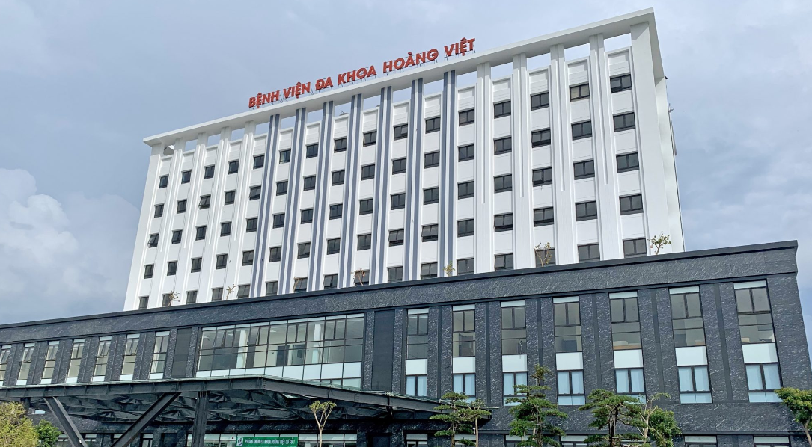
Dự Án HOÀNG VIỆT HOSPITAL – Tuyên Quang
Khởi công năm 2023.
Nhà thầu thi công: CÔNG TY CP XÂY DỰNG PHÒNG CHÁY CHỮA CHÁY HÀ NỘI
Khách hàng: Fisa

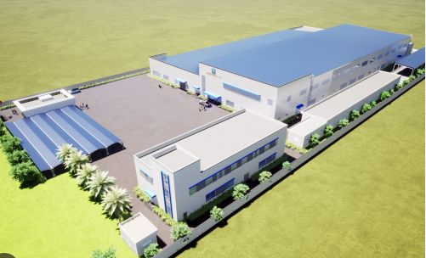
Dự án S-CONNEC - Bắc Giang
Khởi công năm 2023.
Nhà thầu thi công: CÔNG TY CỔ PHẦN ĐỨC PHÚC BG
Khách hàng: Fisa

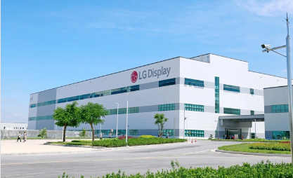
Dự Án H3 - LG DISPLAY factory– Hải Phòng
Khởi công năm 2023.
Nhà thầu thi công: TEMSCO
Khách hàng: Fisa

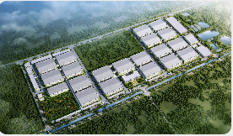
Dự Án GOERTEK NAM SƠN HẠP L ĨNH – Bắc Ninh
Khởi công năm 2023.
Nhà thầu thi công: CÔNG TY CỔ PHẦN XÂY DỰNG HỢP LỰC
Khách hàng: Fisa

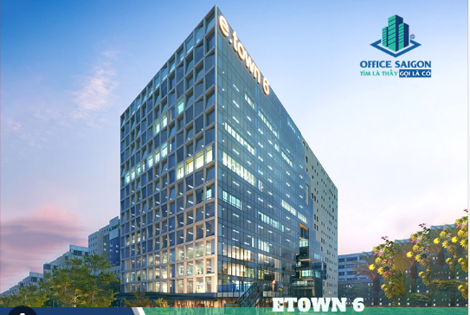
Dự án Cao Ốc Văn Phòng ETOWN 6- Hồ Chí Minh
Khởi công năm 2023 .
Nhà thầu thi công: CÔNG TY CỔ PHẦN DỊCH VỤ & KỸ THUẬT CƠ ĐIỆN LẠNH R.E.E
Khách hàng: Fisa

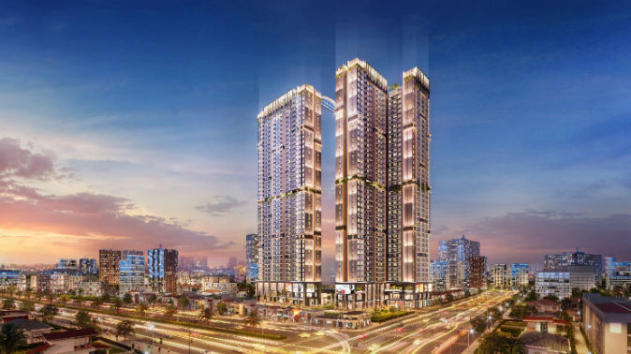
Dự án Happy One- Bình Dương
Khởi công năm 2023 .
Nhà thầu thi công: CÔNG TY CỔ PHẦN XÂY DỰNG CENTRAL
Khách hàng: Fisa

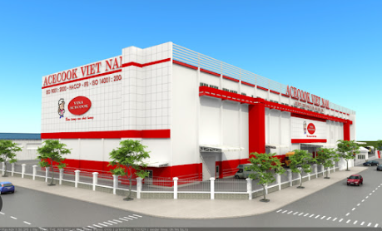
ACE COOK Factory project - Vinh Long
Construction starts in 2023 - 2024.
Construction contractor: KINDEN VIETNAM COMPANY LIMITED

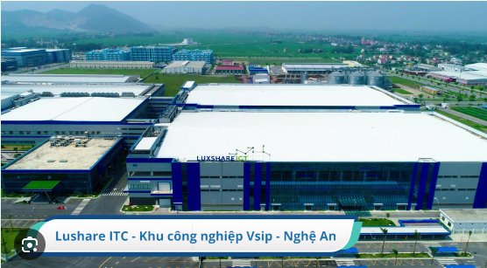
Project series Luxtech, luxshare - D, Luxshare ICT factory - Nghe An
Construction starts in 2023-2024- 2025 :
Construction contractor: HOP LUC CONSTRUCTION JOINT STOCK COMPANY

THE SUN TOWER BASON project - Ho Chi Minh
Construction starts in 2024.
Construction contractor: R.E.E REFRIGERATION ELECTRICAL SERVICES & TECHNICAL JOINT STOCK COMPANY

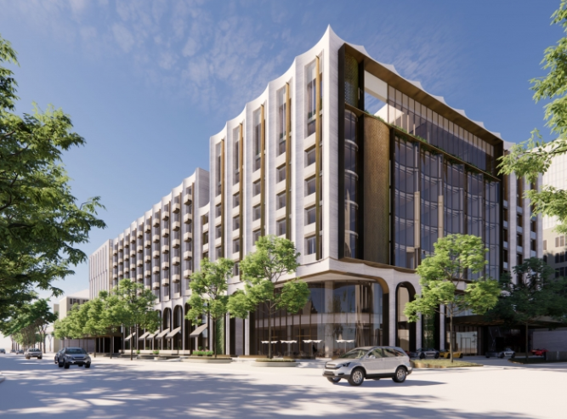
Hotel, Commercial Services and Office Rental Complex – GELEX project – Ha Noi
Construction start year: 2024.
Construction contractor: SIGMA ENGINEERING JOINT STOCK COMPANY

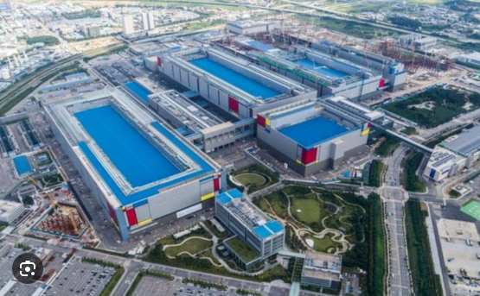
AMKOR project - Bac Ninh
Construction starts in 2024.
Construction contractor: TEMSCO COMPANY LIMITED ; TH VN TRADING CONSTRUCTION COMPANY LIMITED

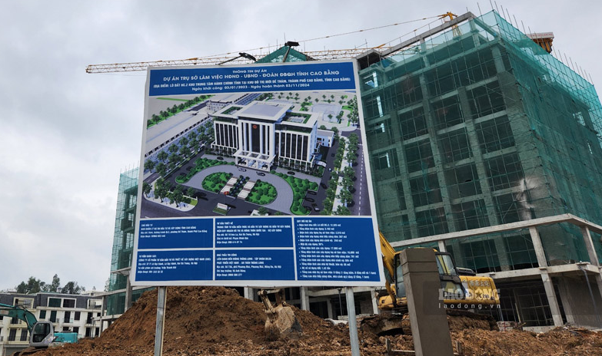
Headquarters of the People's Council - People's Committee - National Assembly Delegation of Cao Bang province
Construction starts: April 2024.
Construction contractor: THANG LONG SAFETY TECHNOLOGY COMPANY LIMITED

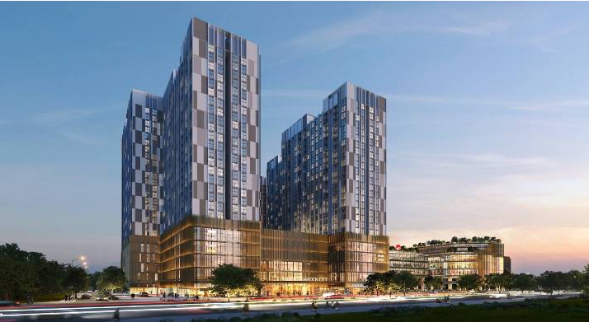
CT1 Hinode Royal Park Apartment Building Kim Chung Di Trach Hoai Duc – Ha Noi
Construction starts: June -2024.
Construction contractor: ECOBA MECHANICAL AND ELECTRICAL COMPANY LIMITED

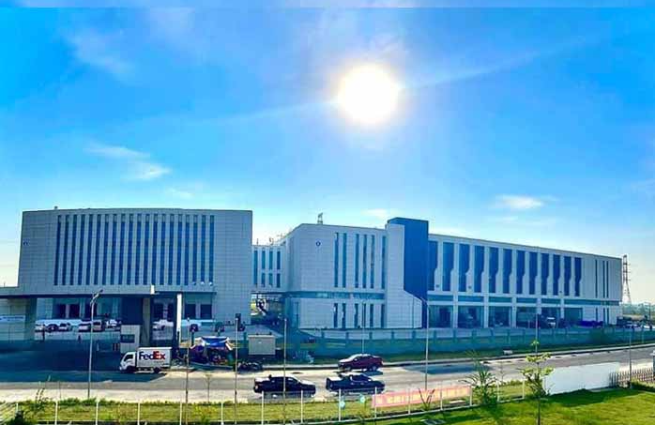
TONGWEI Project - Hai Phong
Construction starts in 2024
Construction contractor: SHANGHAI BAOYE GROUP COMPANY LIMITED (CHINA)

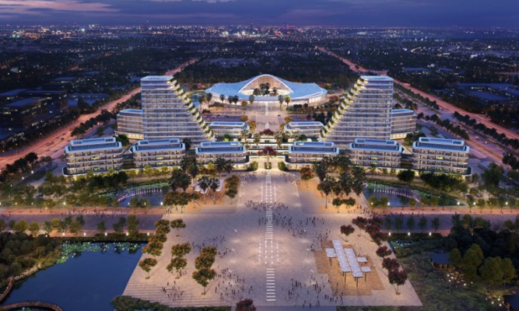
Hai Phong Administrative Center Project - Hai Phong
Construction starts: June 2024.
Construction contractor: BRANCH OF BCA - THANG LONG ONE MEMBER COMPANY LIMITED IN HAI PHONG

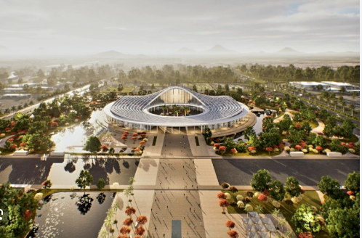
Convention Center Project - Hai Phong
Construction starts in 2024.
Construction contractor: BRANCH OF BCA - THANG LONG ONE MEMBER COMPANY LIMITED IN HAI PHONG

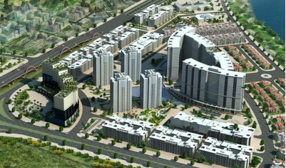
WATERFRONT CITY DEVELOPN Project - Hai Phong
Construction starts in 2024
Construction contractor: GLOBAL FIRE SCIENCE TECHNOLOGY JOINT STOCK COMPANY
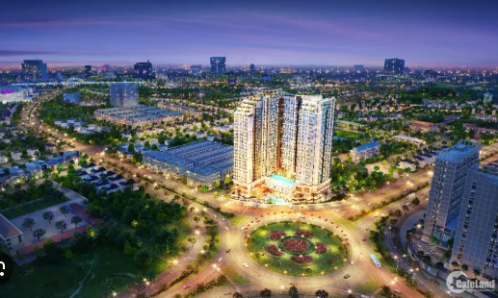
SENTOSA Project - Hai Phong
Construction starts in 2024.
Construction contractor: HANOI FIRE PROTECTION CONSTRUCTION JOINT STOCK COMPANY

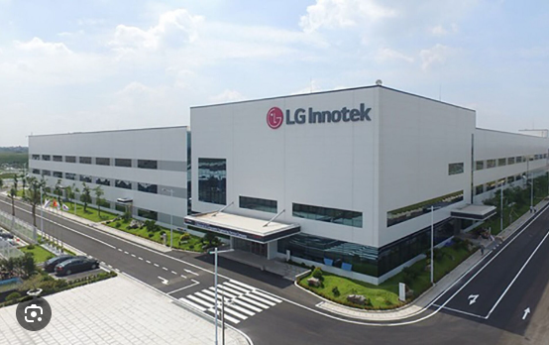
LG INNOTEK FACTORY – Hai Phong
Construction starts in 2024.
Construction contractor: TEMSCO COMPANY LIMITED .

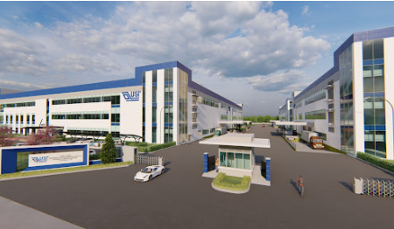
USI project– Hai Phong
Construction starts in 2024.
Construction contractor: TRANG AN
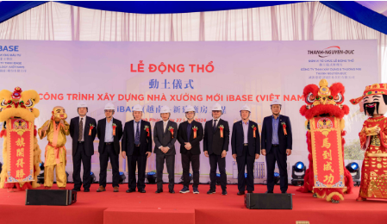
IBASE FACTORY – Vinh Phuc
Construction starts in 2024.
Construction contractor: FISA

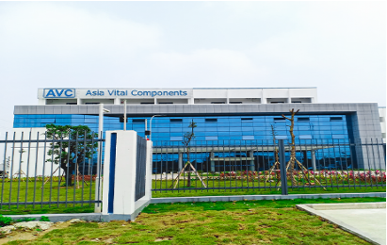
AVC project– Ha Nam
Construction starts in 2024
Construction contractor: TRANG AN
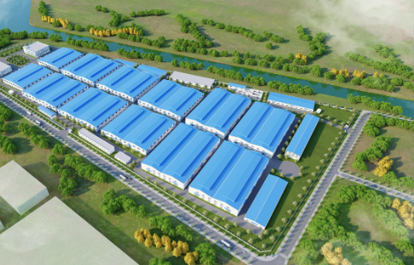
BE RIGHT Factory project– Thai Binh
Construction starts in 2024.
Construction contractor: HOP LUC CONSTRUCTION JOINT STOCK COMPANY
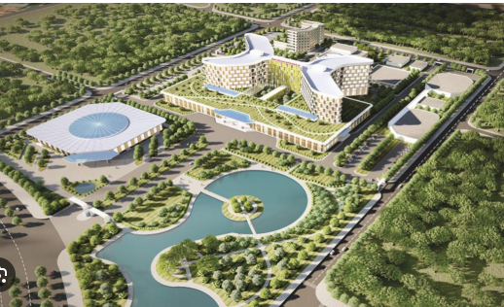
Nghe An Oncology Hospitalproject– Nghe An
Construction starts in 2024.
Construction contractor: TRAN DUY

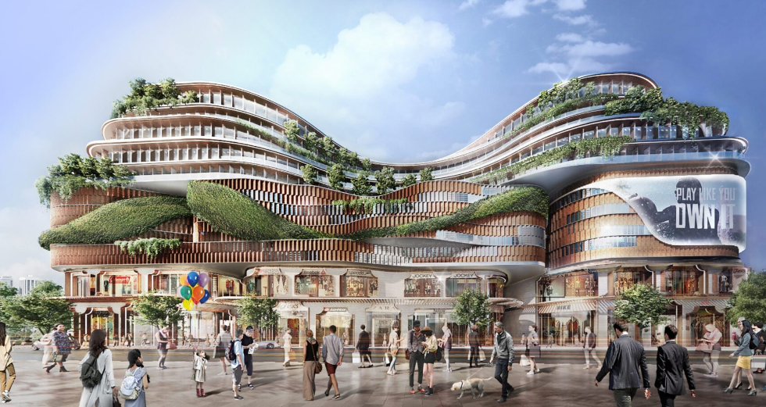
TIEN BO PLAZA - Ha Noi
Construction starts in 2024.
Construction contractor: SIGMA ENGINEERING JOINT STOCK COMPANY

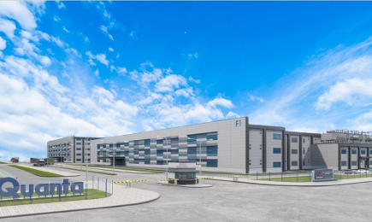
QMH factory project- Nam Dinh
Construction starts in 2024.
Construction contractor: QUANG HA COMPANY LIMITED

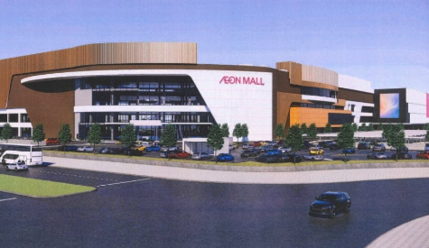
AEON Project - Hue
Construction starts in 2024.
Construction contractor: BCA ONE MEMBER COMPANY LIMITED BRANCH - THANG LONG

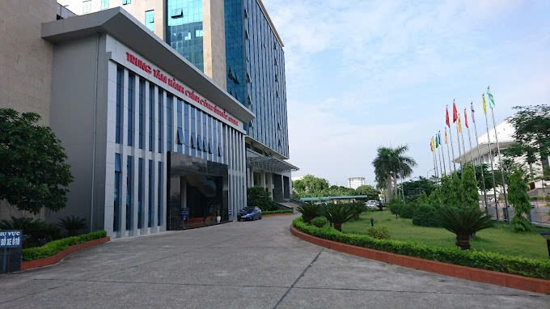
Inter-agency project– Bac Ninh
Construction starts in 2024.
Construction contractor: Airpower Joint Stock Company

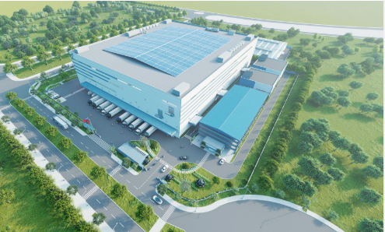
FUHAI Science and Technology Factory Project – Bac Giang
Construction starts in 2024.
Construction contractor: MAX Vietnam Electromechanical Company Limited

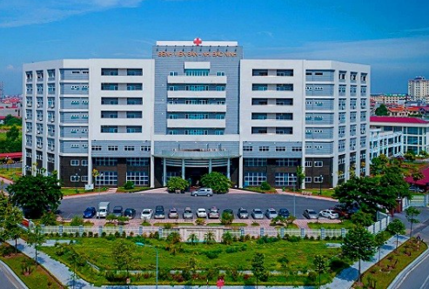
Bac Ninh Maternity and Pediatrics Project – Bac Ninh
Construction starts in 2024.
Construction contractor: MINH CHAU FTC TRADING SERVICES & PRODUCTION INVESTMENT COMPANY LIMITED

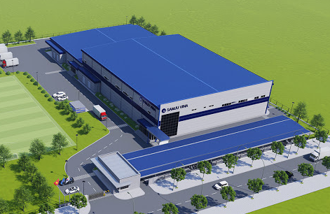
SAMJU VINA FACTORY ( PHASE 2) – Thai Nguyen
Construction starts in 2024.
Construction contractor: THANH AN TECHNOLOGY CONSULTING JOINT STOCK COMPANY

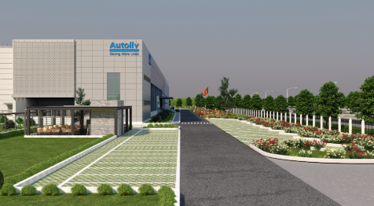
AUTOLIV Project – Quang Ninh
Construction starts in 2024.
Construction contractor: TRANG AN

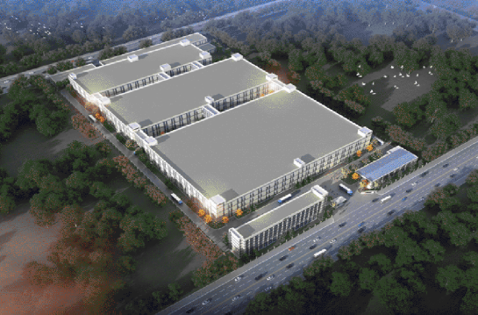
BOE Factory Project – Ba Ria Vũng Tàu
Construction starts in 2025.
Construction contractor:

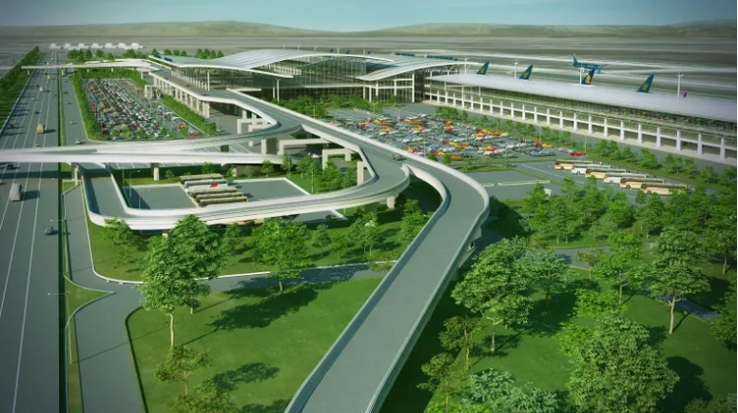
STATION T2 NOI BAI project- Hanoi
Construction starts in 2025.
Construction contractor: BCA ONE MEMBER COMPANY LIMITED BRANCH - THANG LONG

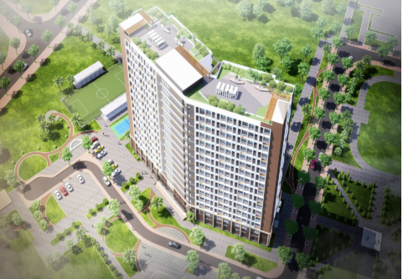
15-storey student hotel: part of Dai Nam University Project
Construction starts in 2025.
Construction contractor: NHAT DUONG COMPANY

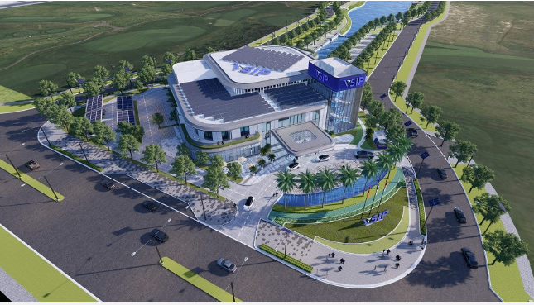
PANDORA Project – Binh Duong
Construction starts in 2025.
Construction contractor: Shinryo Vietnam Corporation

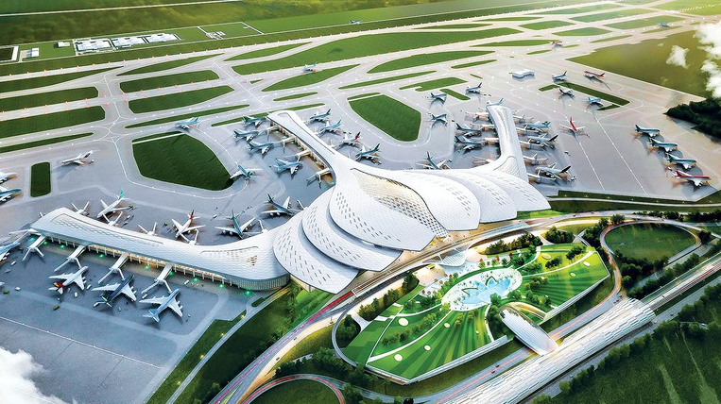
LONG THANH AIRPORT – Dong Nai
Construction starts in 2025.
Construction contractor: BCA One Member Co., Ltd - HCM

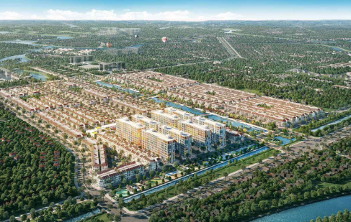
Sun Urban City (Sun Group) – Ha Nam
Construction starts in 2025.
Construction contractor: COTECCONS CONSTRUCTION JOINT STOCK COMPANY

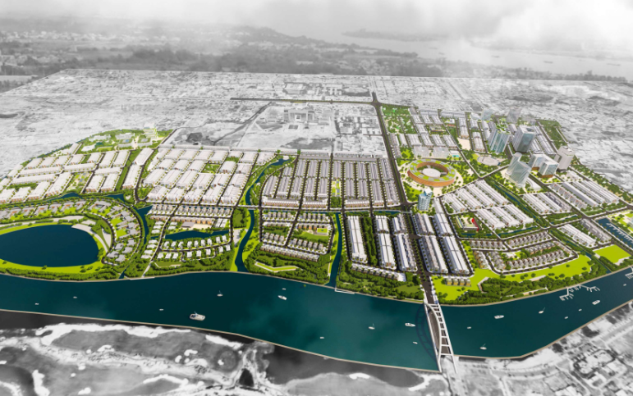
FPT COMPLEX – Da Nang
Construction starts in 2025.
Construction contractor: THANG TIEN TECHNICAL JOINT STOCK COMPANY

VIHA COMPLEX – Hanoi
Construction starts in 2025.
Construction contractor: Xuan Loc Tho Company Limited
CÔNG TY TNHH MTV DAEJIN SANUP VIỆT NAM
Giám đốc
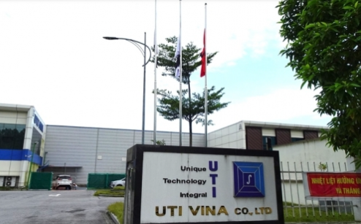
UTI Vina factory – Vinh Phuc
Construction starts in 2025.
Construction contractor: HAI LAP FIRE PROTECTION DESIGN AND CONSTRUCTION CONSULTING COMPANY LIMITED

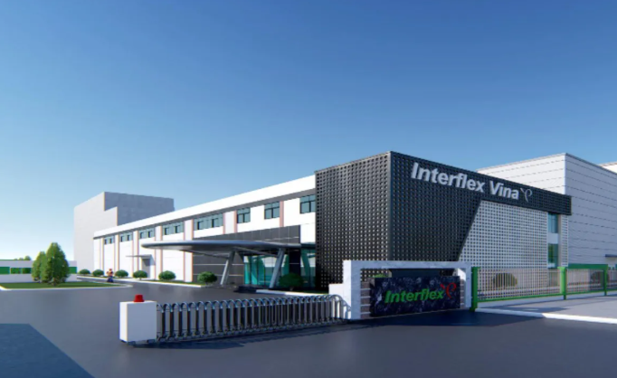
Interflex ( Đồng Sóc ) – Vinh Phuc
Implementation Schedule: 2026.
Project Distributor: FISA Vietnam Co., Ltd.

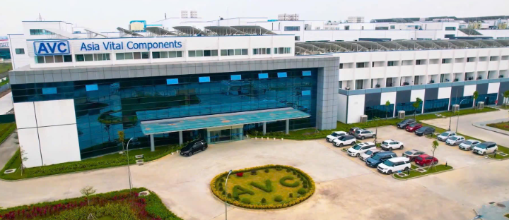
AVC technology - Ha Nam
Implementation Schedule: 2026.
Project Distributor: FISA Vietnam Co., Ltd.

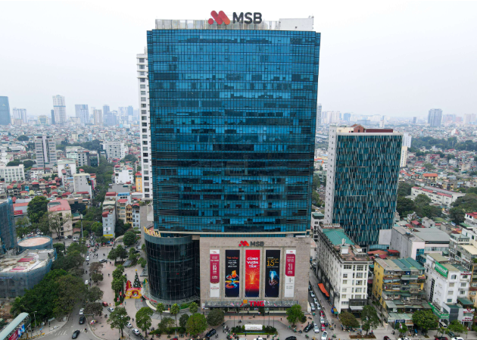
PROJECT: Renovation of MSB Head Office, 54 Nguyen Chi Thanh, Hanoi
Implementation Schedule: 2026.
Project Distributor: FISA Vietnam Co., Ltd.

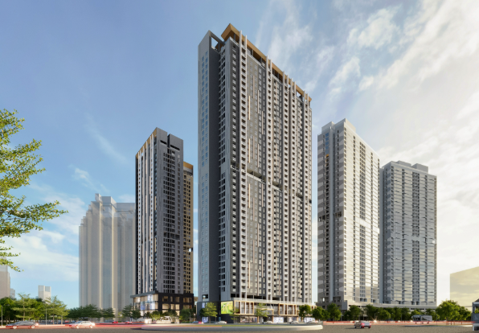
The Matrix One 2 project
Implementation Schedule: 2026.
Project Distributor: TRANG AN TECHNOLOGY AND TRADE SERVICES JOINT STOCK COMPANY
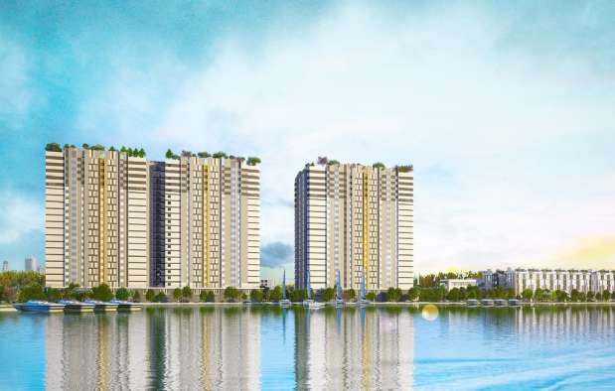
HIM LAM THUONG THANH project
Implementation Schedule: 2026.
Project Distributor: FISA Vietnam Co., Ltd.


The Nam Khang Resort Residences project – Da Nang
Implementation Schedule: 2026.
Project Distributor: FISA Vietnam Co., Ltd.


Hilton Hotel Project
Implementation Schedule: 2026.
Project Distributor: FISA Vietnam Co., Ltd.
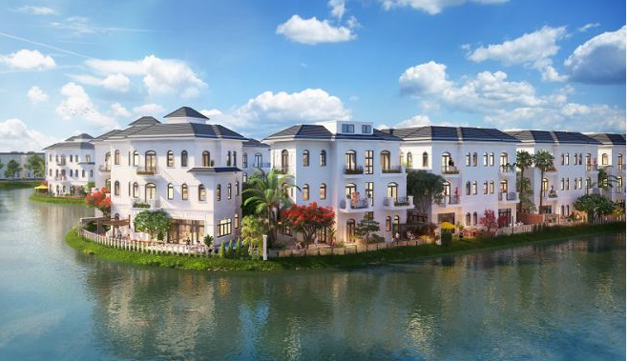
Vinhomes Star City Thanh Hoa Project
Implementation Schedule: 2026.
Project Distributor: ZENIT JOINT STOCK COMPANY
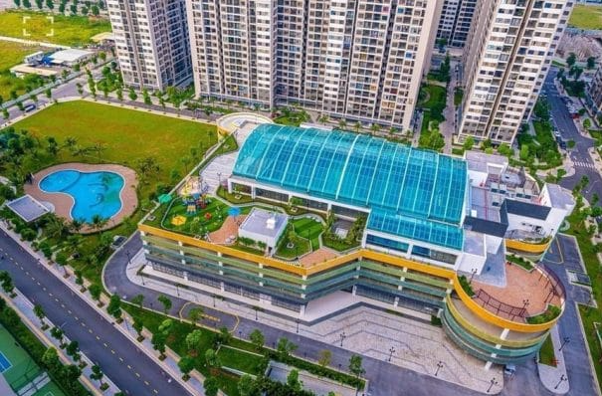
Vinhome Ocean Park project series Project
Implementation Schedule: 2026.
Project Distributor: ZENIT JOINT STOCK COMPANY

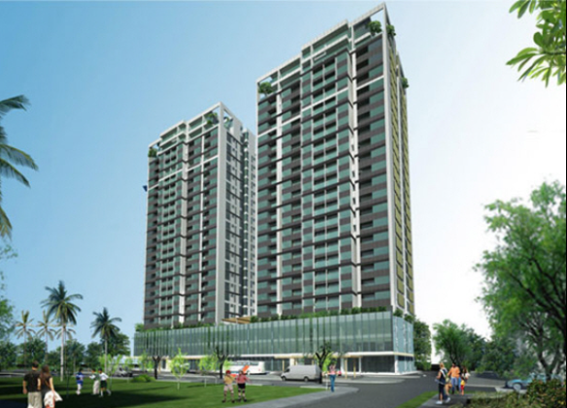
Dream City CT03 Apartment Building Project
Implementation Schedule: 2026.
Project Distributor: FISA Vietnam Co., Ltd.
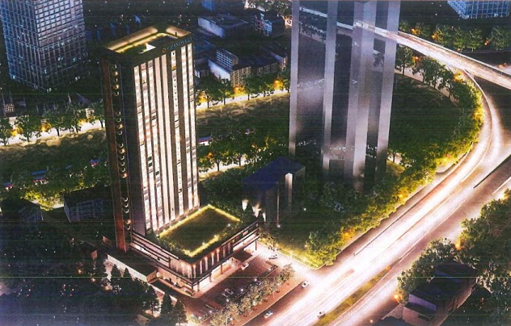
Route Inn Hotel Project
Implementation Schedule: 2026.
Project Distributor: FISA Vietnam Co., Ltd.

DAEJIN SANUP VIETNAM CO., LTD.
Sale Department.

